COURSE REGISTRATION WEBSITE (LAB ASSIGNMENT 1)

In this assignment I have created a course registration website, in which students can enroll into their desired courses.

As the first step I have created a home page in which, students are required to populate some dropdowns, according to their selections, they are navigated to the appropriate pages.

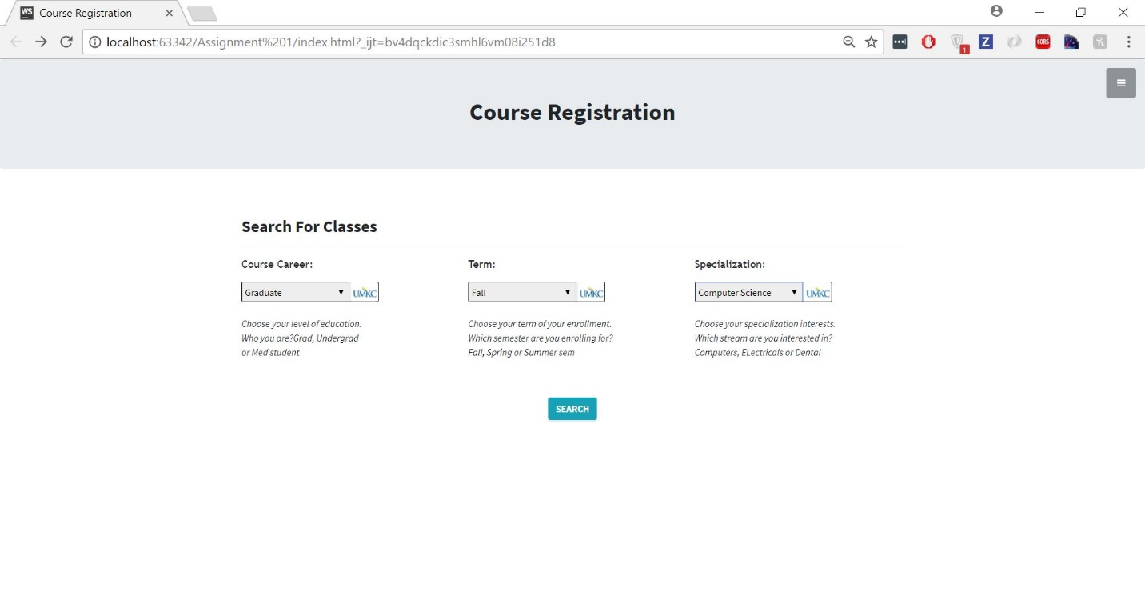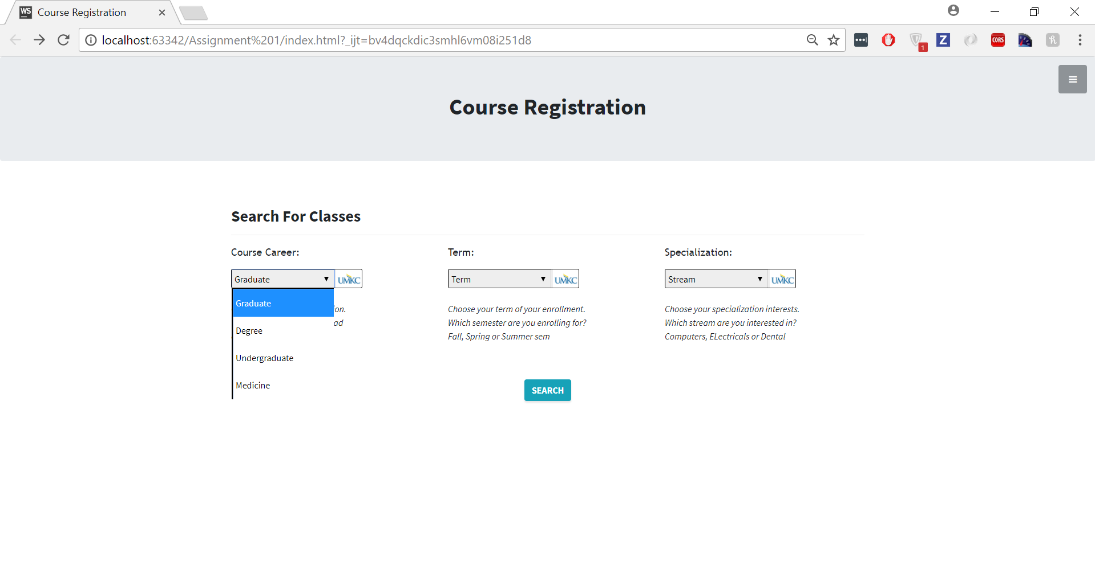

The above pictures show the homepage of the website, also the dropdown options are shown below.

The search is modified every time we select different combinations of the options. The below code shows its implementation.

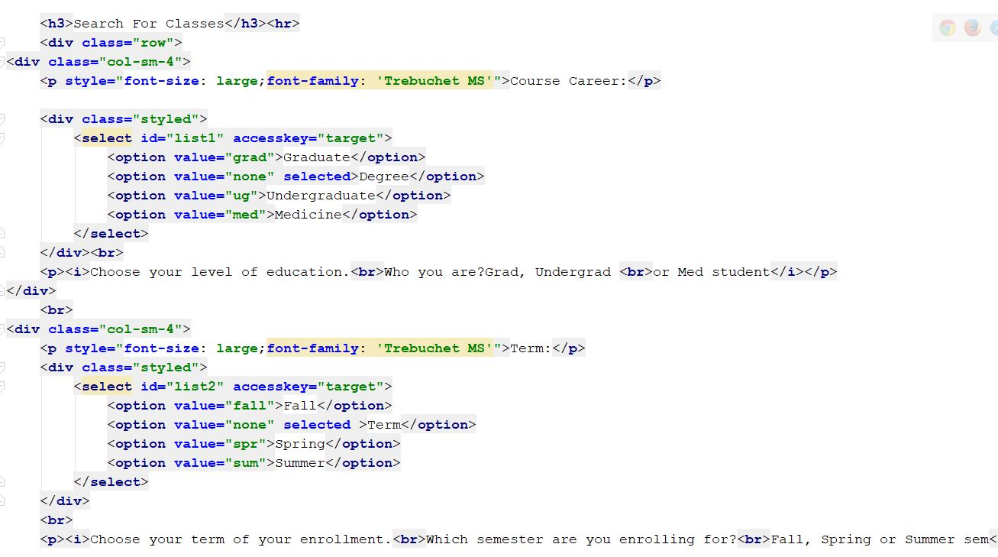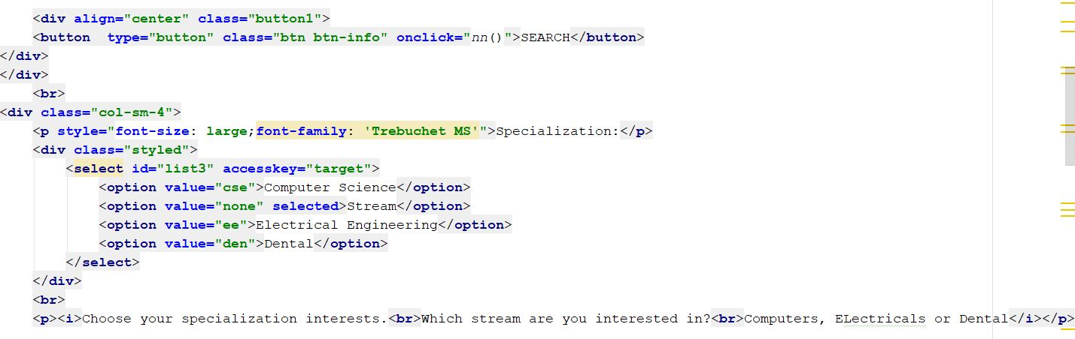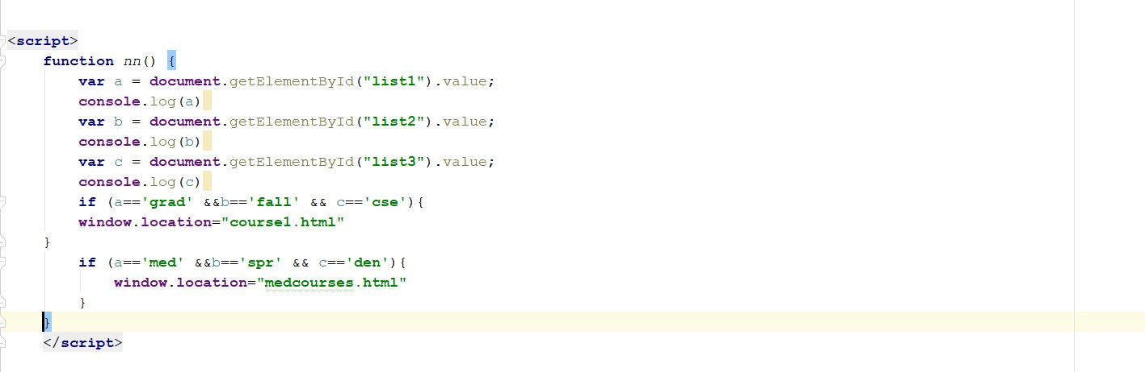

Then we are navigated to appropriate pages. Below images show these pages.



The first two images show CS courses, while the last two show medicine courses. For each course, Instructor name, course description, prequisites ,credit hours along with duration are shown.

The images are clickable, and they direct the user to the respective course enrollment pages. Also links for similar courses are provided for each course.

When we click on enroll we are directed to the enrollment page as shown below.



In this page, the user is provided information about no. of seats available, classroom, class hours along with ratings and reviews.

Whenever we enroll into the course, the user is shown a image saying he is enrolled as shown below.



And accordingly, the number of seats decrease when the user enrolls into the course as shown in below pic.



It is implemented using the below code.

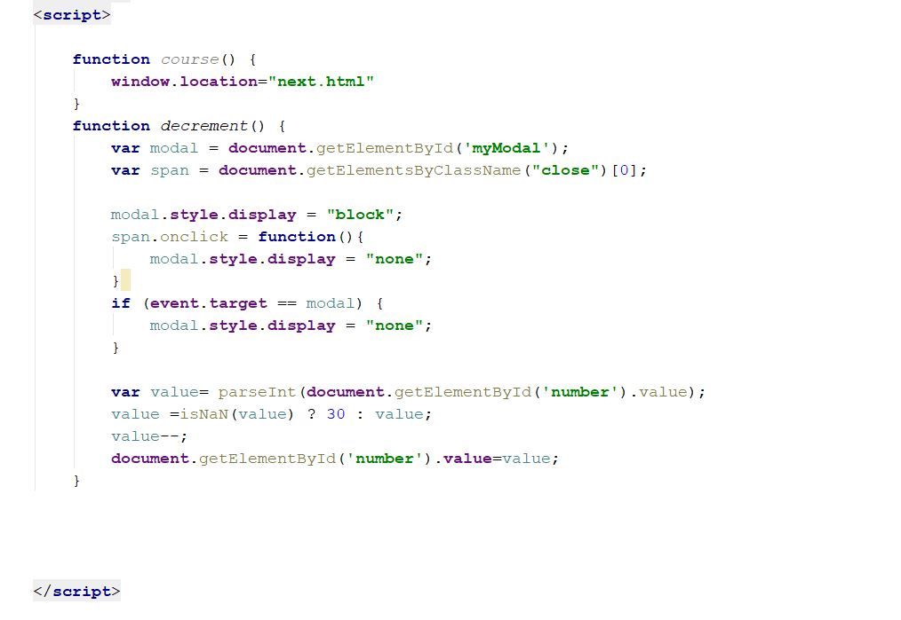

Similarly, it is done for all the courses.